Search Engine Marketing

Advertising through search engines like Google is an effective way to ensure that your website has an advantageous spot within search results when a consumer is searching for a site or product. Most companies employ SEM as an effective inbound tactic for reaching their target audiences, searchers, as it connects your content to an already interested consumer and supports the widely held belief that consumers are far more likely to click on one of the first search results. When a company uses search advertising through the engine, they bypass the ad ranking putting its site at the top before organic results, and they are often PPC ads, which require payment to the search engine when someone clicks on your ad. SEM is effective at increasing the conversion likelihood because its connection to a search ensures an interested consumer, but it can be a competitive type of advertising, as it features modified second-price auction systems, which have companies competing to pay the amount necessary to be on top of the page. SEM, in conjunction with SEO optimization and a well-designed website, will drive highly interested traffic to your site, based on consumer needs.

Ad #1

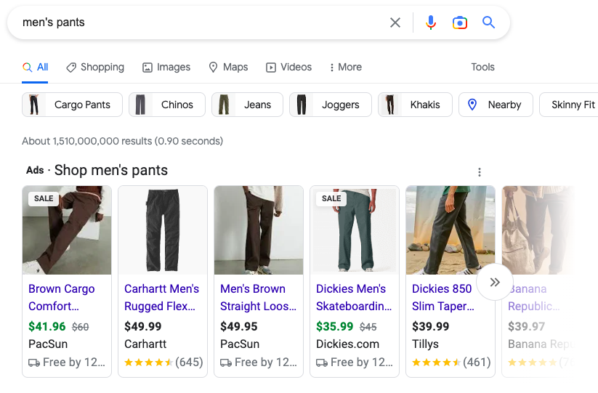

These Ads, which I found by searching for the phrase “men’s pants” on Google, are great examples of how companies use SEM to present their products first when consumers search for a product category. This section is at the top of the search page and labeled “Ads - Shop men’s pants”, and is focused on creating conversions by centering photos of products. While sites that have not utilized SEM would need to first get the consumer to enter their site, this tactic creates an immediate shopping experience and shows products that are applicable to the consumer’s search, effectively creating an easy shopping experience that is more likely to lead to a conversion.

Ad #2

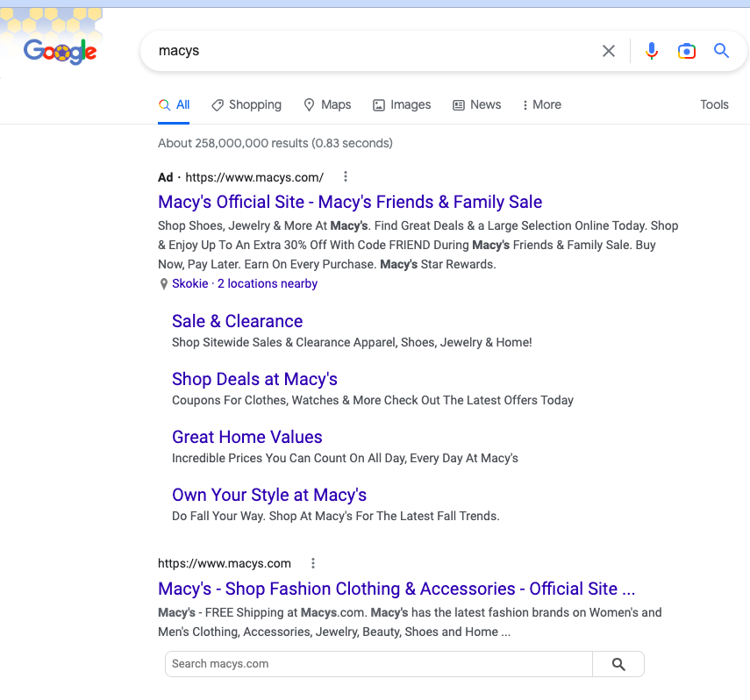

Ad #2 is an example of when SEM tactics can end up being less successful at creating unique impressions, as they sometimes lead to a paid conversion that may have already been organic. Here I searched for “macys” on Google, which is a specific search for a brand and is likely not a competitive category for the search engine. The engine shows me the SEM ad first, and then directly below it is the search-engine-optimized site. A consumer who searches like this is very likely to click on the Macy's website, but if they click on the top result, Macy’s will be charged for that conversion despite the specificity of the search. This ad is ineffective at creating unique impressions and conversions and may be a waste of advertising resources, although I am certain that Macy’s effectively uses SEM on different search terms.

Ad #3

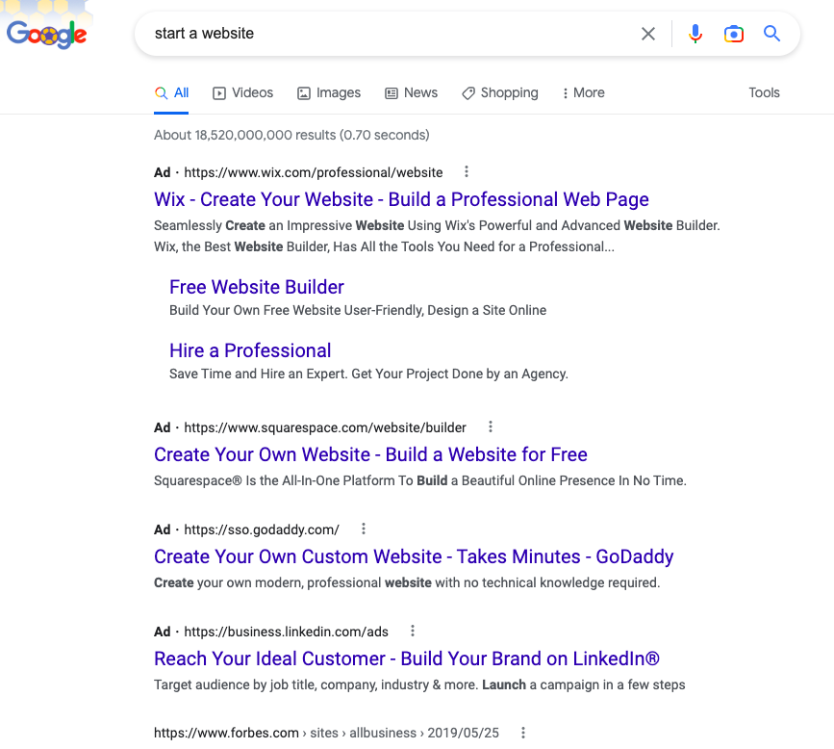

The ads in this screenshot were found when I searched a desire that a consumer could have, “start a website” on Google, to determine what sites are effectively using SEM in this crowded category. Here, the website creator WIX is able to most effectively place their ad on the page, which displays promises of a “Free Website Builder” and the command “Build a Professional Web Page”. This is an effective way for Wix to create conversions, as they are responding directly to a consumer desire that they have searched for and provided the resources they are looking for. There are many website builders online, and it may be difficult to get consumers’ attention. This use of SEM is maximally effective at engaging with interested, motivated consumers and increasing conversion likelihood by being at the top of the search page

Display/Banner Ads

Display/Banner Ads refer to the practice of displaying small advertisements on third-party websites that attempt to interest the consumer, get them to click the ad, and take them to their page. These third-party channels sell ad space to advertisers that usually occupy the margins of the page and frame the website’s content. Banner ads are very popular, as there is ample space, they tend to be cheaper, and they are good for frequency. Display ads tend to get an average CPM of around 2.80 USD, and they are generally associated with low conversion rates and value. Display and Banner ads usually have a lower click rate and sometimes come with a high bounce rate once on the site, but they can be an effective tool for exposure and familiarising the consumer with your product or website.

Banner Ad #1

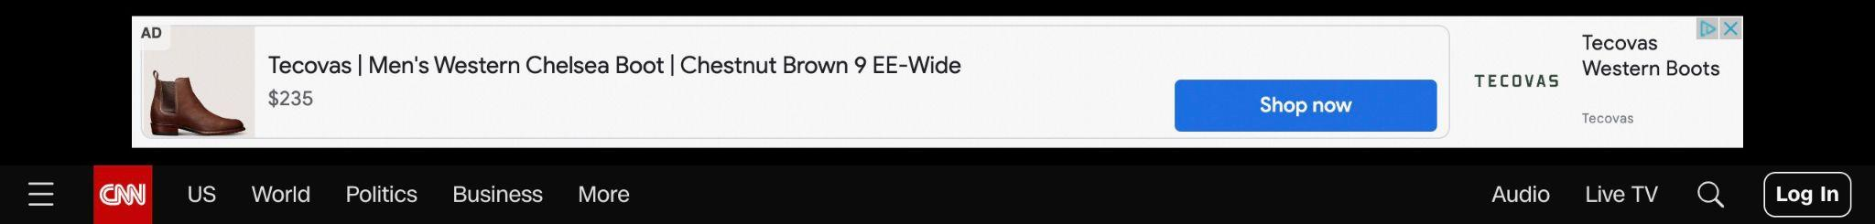

This ad, which I found by clicking on the first article on the CNN home page, is an advertisement for Tecovas Men’s Western Chelsea Boot, which is a product that accurately targets my demographic and online habits, most likely based on my cookies. The size and position of this ad, featured at the very top of a page containing a recent news article, makes engaging with or clicking it less appealing, and a consumer may be less likely to notice it. It features lots of negative space, and the size and small type face make it somewhat difficult to identify the product and become interested. While the ad was already at a disadvantage because of the position and proximity to important news, the design of this banner ad makes it unlikely that a consumer would notice it, become interested, and purchase the boots.

Banner Ad #2



Banner Ad #2 occupies a similar ad space to #1, above a recent news article on NBC news that I found by clicking the first article, but this ad does a better job of utilizing the space graphically. Although it doesn’t present much company info, the large pictures create a higher likelihood for the consumer to become interested, want to learn more, and click the ad. This ad, which is for a real estate website in Spain, also seems to target the demographic that reads NBC news somewhat effectively, as the audience tends to be older people who may be homeowners. I think that is ad effectively uses the space to interest the consumer and create a click as best as it can with the ad space.

Ad #3

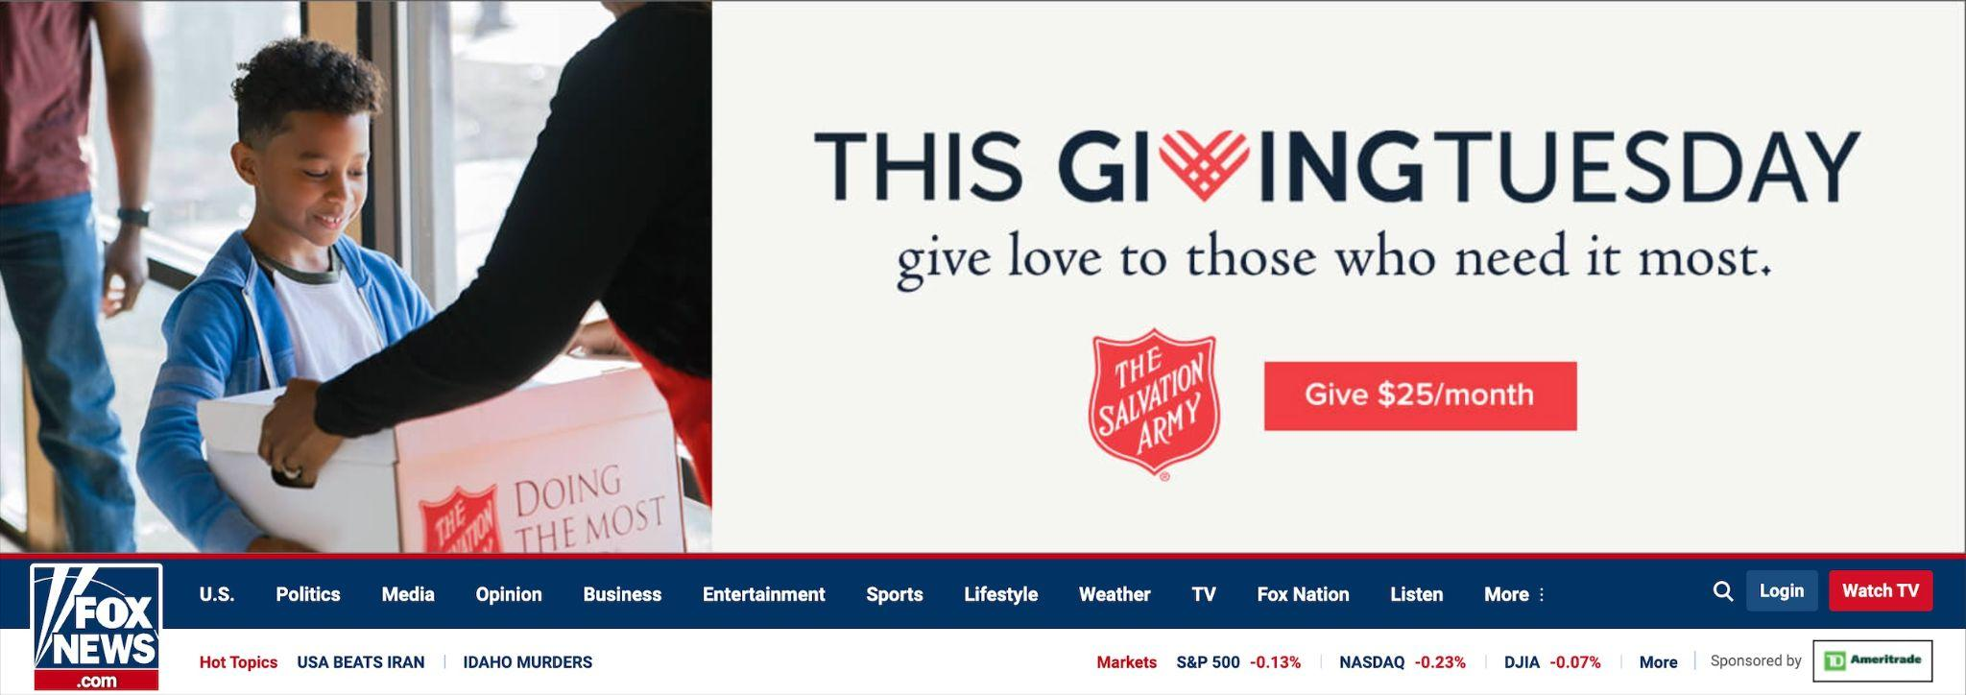

This advertisement, which I found again by clicking the first article on the FOX NEWS site (with the hopes of comparing the three political channels’ ads), is a topical ad from the Salvation Army, which asks FOX readers to take the holiday of “Giving Tuesday” to donate to the site. This ad has a much more advantageous size on the page than the previous ones and employs a sweet and emotionally stirring picture to move the consumer into donating. It provides a clear place to click and donate and includes an emotional plea to “give love to those who need it most.” This is an effective, high-impact use of a banner ad, as the space is much more effective at engaging the reader, and it is able to employ several tactics to get a click within the space. I also believe that this is likely a good pairing with the FOX NEWS reader or me (whose cookies drive the ad selling to some extent), as it is entirely apolitical and appeals to many types of people.

Native Advertising

Native Advertisements are ads that attempt to mimic the style, content, form, and function of the media platform they are advertising on, in order to decrease the consumer’s awareness that they are being marketed to. These ads often take the form of Advertorials, which are created content that consumers can engage with alongside their news which embeds advertising messages in the form of an article. While Native Advertisements are not the most popular form due to their somewhat controversial nature, they are becoming prevalent because they override consumer Ad fatigue and engage them in a new way. Native Ads tend to overperform by commanding higher premium CPMs, as it tends to lead to stronger engagement. A company can somewhat effectively target demographically through native advertising, as long as its target audience falls in line with the readership of the host platform. Native content can lead to higher conversion value and is an effective tactic for inbound marketing when done ethically.

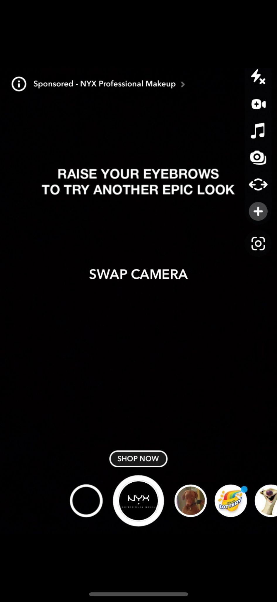

NA #1

This piece of Native Advertising that I found while looking through the lenses on Snapchat is an interactive ad from the makeup company NYX, which blends in with the noncorporate sponsored camera effects that Snapchat is famous for. This frame asks the consumer to allow NYX to digitally give the effects of some of their products to their face, in hopes that they may be inspired by the look and click the “SHOP NOW” button. The call to action, which says, “RAISE YOUR EYEBROWS TRY ANOTHER EPIC LOOK,” sets a fun and social tone that blends in well with other Snapchat frames. This is an effective native ad because it is an actual piece of media for the consumer to engage with and does not take away from the regular experience of taking a Snapchat photo. It also allows the consumer to try to effects of the product in a fun way that doesn’t feel like an ad, while still effectively leading the customer to the website.

NA #2

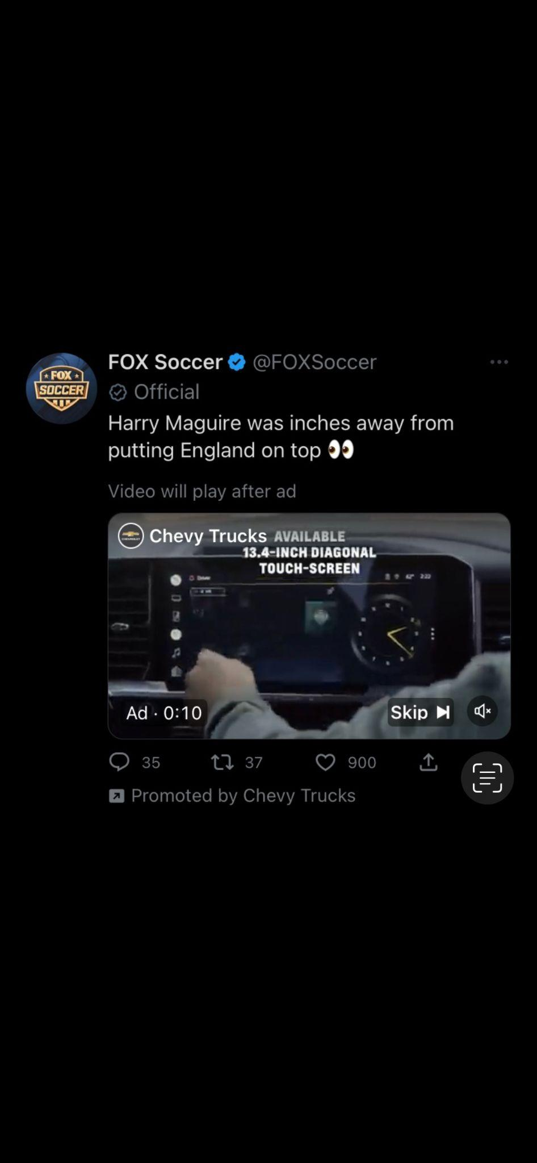

This native Ad, which I found while scrolling through my feed on Twitter, is an ad that attaches itself to a tweet from the FOX Soccer account, which allows it to mimic the style and tone of regular tweets to promote Chevy Trucks. The ad attempts to blend into the Twitter feed by making a comment on a topical event that many people are tweeting about, the FIFA World Cup, and providing an entertaining video for fans to watch. Although, before the video, the consumer must watch an Ad for Chevy Trucks, and the company has promoted the FOX Soccer tweet in order to get more eyes on their ad before the video. This is a good way for Chevy Trucks to get an advertising message out that seamlessly blends into the form and function of Twitter, as it is attached to a real tweet. Especially because the video contains content about contentious soccer rivalries that many fans will want to watch, this ad effectively reaches an audience of soccer fans while blending into the Twitter feed.

NA #3

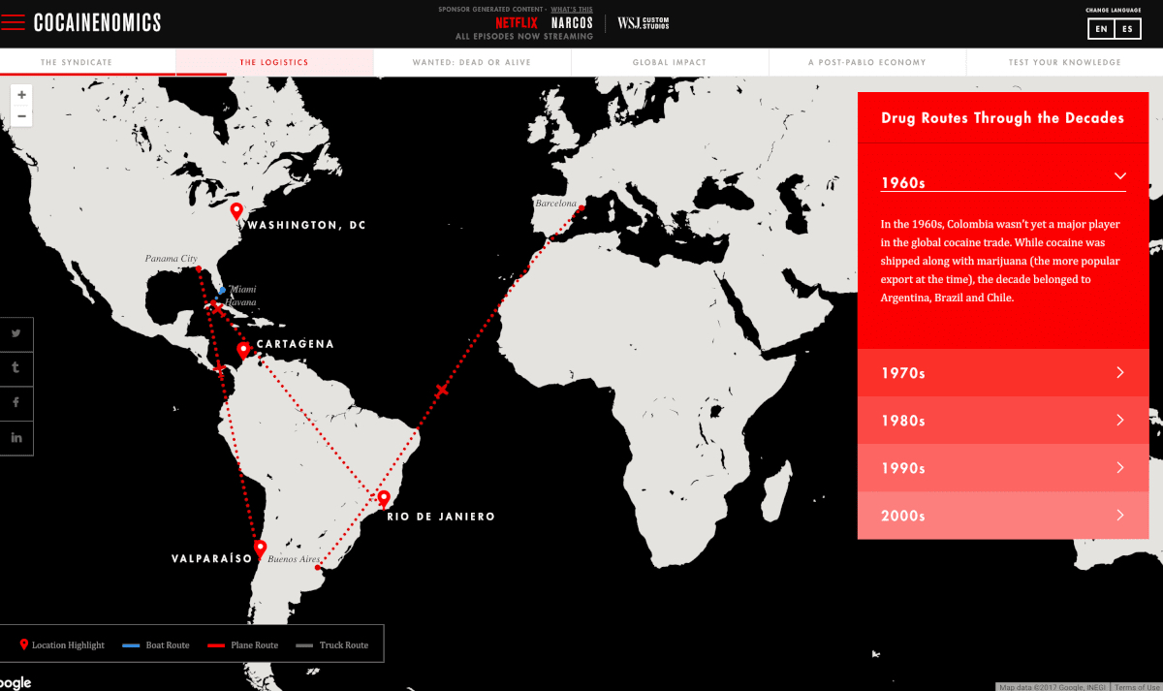

This advertisement, which I found while searching for Native Ads in *The New York Times*, is an interactive map, entitled “Cocainenomics”, that reveals routes that illegal drug trades took through different decades in order to promote Netflix’s show *Narcos.* A reader can click through different tabs full of interesting information on the drug trade’s logistics, impact, main actors, etc. This is an effective piece of native advertising because it is beautiful and fun to use, and it perfectly fits the form and function of other *New York Times* interactive maps. It does not take away from the map that it is an ad or overly drill in the advertising message. Instead, it seeks to drum up more general interest and raise awareness for the topic that *Narcos* explores, while still using that interest and publicity to create new Netflix subscribers or *Narcos* watchers. The depth of information on the slides accurately mimics articles, and I believe that many people could engage with this map, become interested in the show, and not click off due to ad fatigue.

Influencer

Influencer marketing refers to the strategy of companies partnering with online thought-leaders who have fostered a devoted community of followers and using their swaying power to advertise products or services, often on social media. This can include influencers endorsing or publicly using a product to their followers, who listen to the endorsement because of the influencer’s expertise or influence and are more likely to engage with the company. Influencer advertising is extremely popular and has created an entirely new industry of social media professionals because of its nearly unrivaled ability to target certain customer demographics. This is because the specificity of many influencers’ communities creates a great avenue to advertise to clients whose interests make them likely customers. CPMs for influencer marketing tend to be around the $3-20 range, dependingly widely on the influencer, and feature a high conversion value because of the likely high level of interest of the consumers. This is an effective tool for reaching a highly interested group and is good for frequency within the feeds of likely consumers. Influencer marketing is an important and popular part of online advertising that is an effective way to create conversions.

Influencer Ad #1



This Instagram Ad that features influencer Addison Rae features a video of Rae using and endorsing Google phones and its ability to recognize songs, which is a product feature that Google has focussed on in many ads. The video, which sits in Rae’s Instagram grid, features her unable to recognize a song, using the Google phone to solve her problem, and then dancing (which is what made her famous). This video is effective influencer marketing because it does not just feature an endorsement from her, but the video of her using the product, smiling, and having fun is a much more personal and persuasive endorsement. Addison Rae is one of the top influencers in the world right now, with millions of devoted followers who are within the consumer market that could potentially purchase a Google phone. This ad does not attempt to blend into her feed, instead choosing to function more as a commercial that goes directly to her audience via her Instagram page. For Rae’s followers, seeing her interact with the phones, especially in a fun setting and context, will be a persuasive influence on how her fans see the Galaxy S22 phone.

Influencer Ad #2 

This example of influencer advertising features Noah Beck, who is a popular Tiktok star followed by many young people, which I found while searching on the #AD section of Instagram. This post, on Beck’s Instagram grid, features him meeting Kaka, a famous soccer player from Brazil. The picture features them in front of the FIFA CUP trophy and congratulating the winner of the FIFA Dream Contest, in which Beck was partnered. This FIFA Dream Contest, while not a product being advertised, is a fan art campaign that focuses on engaging soccer fans around the world by asking them to create art that features the FIFA trophy. Beck posts photos with many of the art pieces, encouraging further participation in future FIFA events. This Advertisement is not especially effective at selling a specific product, but it does effectively utilize Beck’s fan base to encourage future engagement with the soccer league.

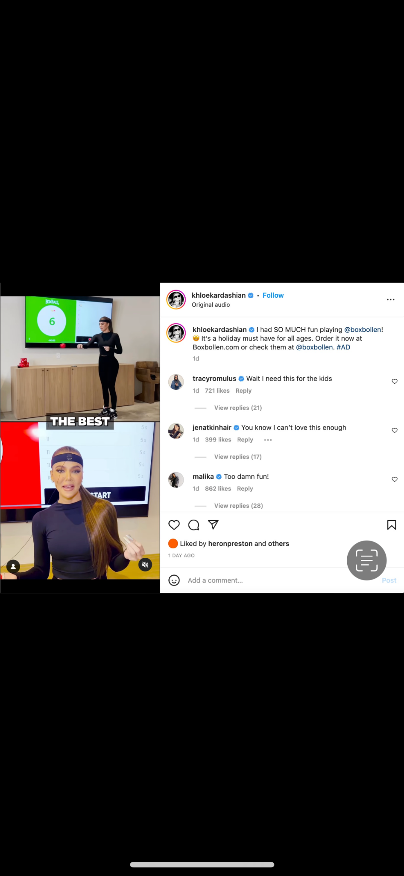

Influencer Ad #3

This ad feature Khloe Kardashian having fun and getting a great workout playing a boxing video game, which I found on the #AD section of Instagram. Khloe endorses the product, calling it a “must have” and calling her fans to purchase it, and uses the game seriously in the video. This is an effective influencer ad because it utilizes one of the largest influencers in the world, but it may be more difficult to target specific demographics because of her wide following. The reach of Khloe’s account is enormous, and the images of her using the program and her kind word about it are a persuasive technique. For a company that wants to create a large outbound reach, this is an effective influencer ad.

Social

Social media advertising refers to earned, owned/created, and boosted media that exists on the page of the company and the consumers that engage with it online. This can be a post in an Instagram feed or story, a tweet, or a pin on Pinterest that advertises a company's products, services, and brand, or a post from a company’s feed that they pay to put into new, targeted people’s feeds. Social media advertising is very popular and is a part of nearly every brand's media strategy, as it is a direct way to connect with consumers and drive advertising messages within their feeds. CPMs for social media advertisement tend to be around $5-10 per 1,000 impressions and are often very effective at targeting demographics because of all the consumer info available through the platforms. Social media ads are often effective at both reach and frequency, depending on the media rollout. A company is able to touch base with loyal fans often or reach new ones. Social media ads have a good conversion value, as they can be highly targeted, and can be used for inbound or outbound marketing. Social media advertising has revolutionized the advertising business by creating a direct line of contact with consumers that is more specific and targeted than ever.

Social Ad #1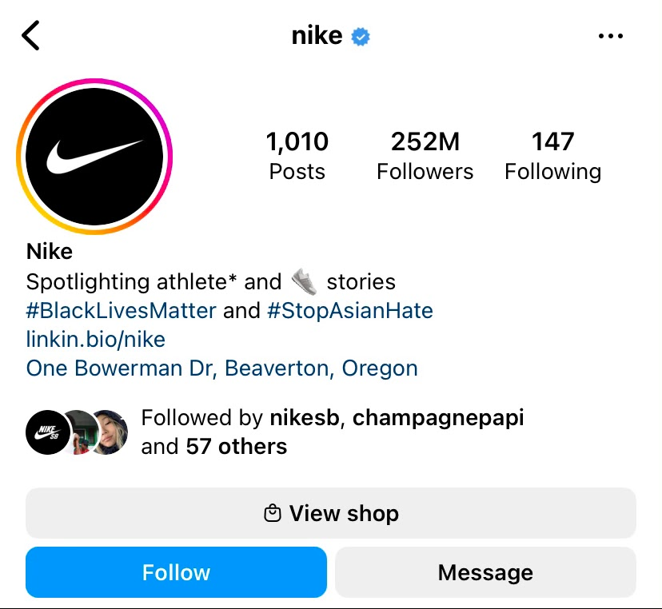

This is Nike’s Instagram page, which I found through Instagram’s search feature. Other than being the place where Nike can connect with their followers, advertise products, and create strong brand associations, its bio is a place to drive clicks and conversion on the website. Here is a place to make their values clear and put forward a bit of copy, but this link is how they move consumers from their owned media on the grid to their website. Instagram also functions as its own shop, with a shopping tab where Nike can use their page to drive sales on the page. This is an effective use of Nike’s owned media and advertising messages on their social media. The Instagram bio is an example of an owned media ad they did not have to pay for but can use to create conversions and clicks. Nike uses this space effectively by creating a clear message and displaying its website link.

Social Ad #2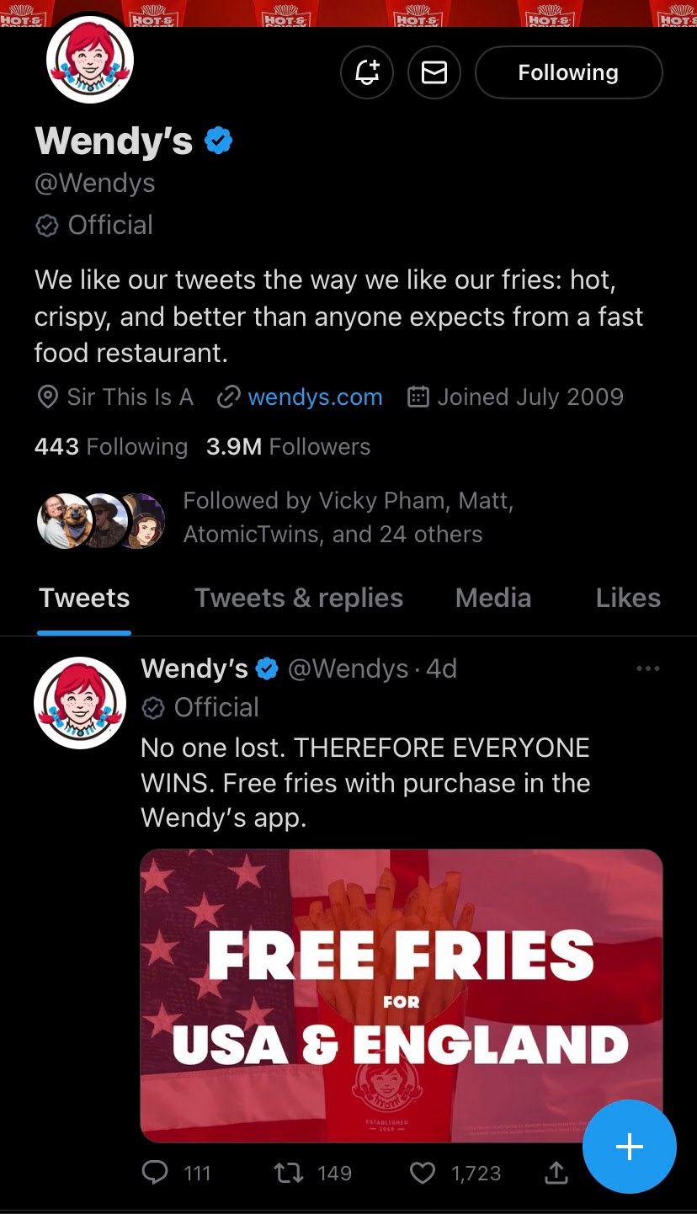

This is an example of another social use of owned media on Twitter, which is Wendy’s often viral Twitter account. Here Wendy’s has created a strong brand voice and effectively used its following to increase brand loyalty and engage their customer. The page’s bio, which sits above its tweets, provides a thesis statement for the page and provides the link to Wendys.com, where a customer can find a Wendy’s location and order food. They also have an interactive element, using their famous meme quote, “sir, this is a Wendy’s,” to create a recognizable call and response to engage the customer. This is a very effective use of a social media page as an ad. Even though it is not solely focused on selling fast food products, it is an expert at creating a recognizable brand for the consumer to engage with, and it shows in its nearly 4 million Twitter followers, who are being advertised to while enjoying fun Tweets.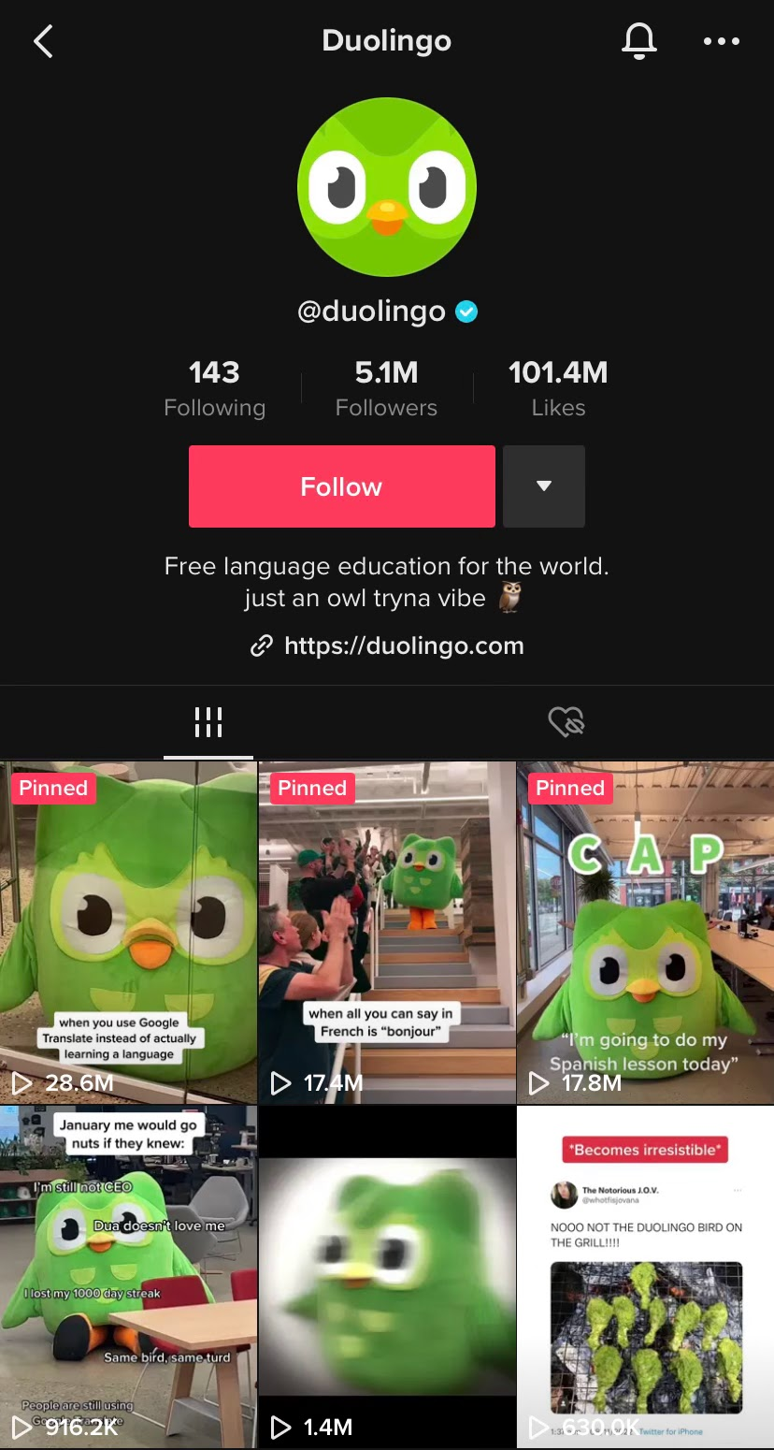

Social Ad #3

Duolingo is another example of how a social media team has used its page to completely revitalize a brand, create a unified and recognizable voice, and increase subscriptions. I found Duolingo’s Tiktok page when it became a sensation a year ago because of its funny Tiktoks that lightly poke at themselves. The Duolingo Owl character came from a frequent observation that the push notifications for Duolingo were overly dramatic, so the social media team took that criticism and created a fun, crazy owl character that is not synonymous with learning a new language. This is an effective use of social media advertising because it adds something fun to the feed for the consumer to enjoy, which makes them far more likely to engage with the program. The page also prominently displays the link to download the app, effectively using the page to create conversions.

Affiliate Marketing

Affiliate marketing refers to the practice of paying a third party a commission for every conversion or visit that they can generate for the site or company. This is different from influencer marketing because of the structure in which you pay the affiliate, even though influencers are often affiliates. Affiliate marketing is effective at coercing those who have highly specific or interested audiences into using their platform to sell products, as well as creating a personal and emotional incentive for the consumer to engage with a brand to support the affiliate. Affiliate marketing is quite popular online, and it is a very effective tool for targeting in a similar way to how influencer marketing is (due to their persuasive power with an often highly specific community). Affiliate marketing is very good for frequency, as it allows you to increase the possible engagement within a smaller community of likely customers. This example of outbound marketing is very effective, as it allows you to reach into a community that previously existed and capitalize on the shared ties within it. Affiliate marketing is an effective alternative or companion to influencer marketing that incentivizes the affiliate to turn their platform into clicks and engage potential customers.

Affiliate Ad #1

This is a classic example of an affiliate code, which I found on a linktree in the Instagram bio of a small-time beauty influencer named Ry Tates who I know from high school. Ry, along with her makeup and beauty content, frequently advocates for using her affiliate link for the underwear brand Parade, which provides you with 20% at checkout. She directs her nearly 3,000 followers to the linktree and Parade website and receives some pay in return. This is a somewhat ineffective use of an affiliate ad, though the risks of affiliate partnerships are less. Tates has a very small audience, so the potential reach of her partnership is very low. Although, because she only makes money when someone uses her code, it is a generally low-risk advertising plan, and she may be very effective at convincing some of her 3,000 followers. These types of partnerships could be effective if they are using many small influencers in their targeted demographic, but the user experience and general difficulty of finding the codes make this only a somewhat effective affiliate advertising plan.

Affiliate Ad #2 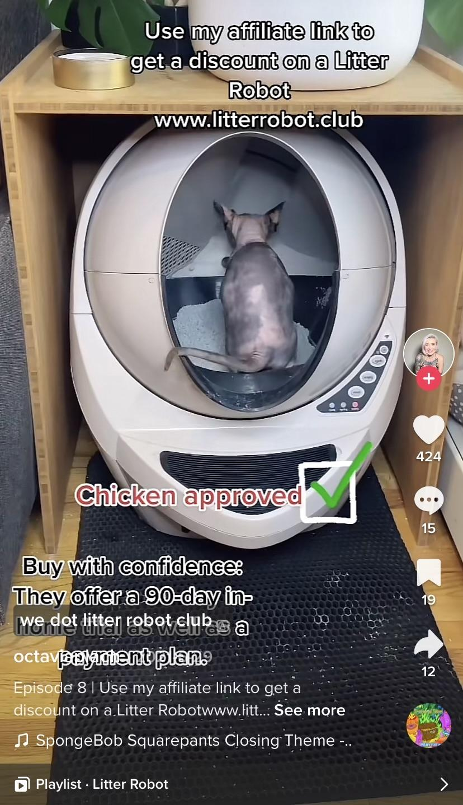

This is an affiliate ad from an account called @octaviaplach that I found while scrolling on Tiktok, which features content about her hairless cat. The product is a Litter Robot, which is a high-tech litterbox for cats, and she provides the website, asks her followers to use her affiliate link, shows her cat in it, and says the cat approves of the product. This is an effective use of an affiliate link because it uses an influencer in a hyper-specific community, in this case, those who are interested in cats, to advertise to a specific demographic. She also provides a compelling and cute visual of her cat using the product which makes it more persuasive to cat lovers. The implied endorsement of the cat, shown by its use of the litter box, again strengthens the potential that a cat owner would use the link and buy this product.

Affiliate Ad #3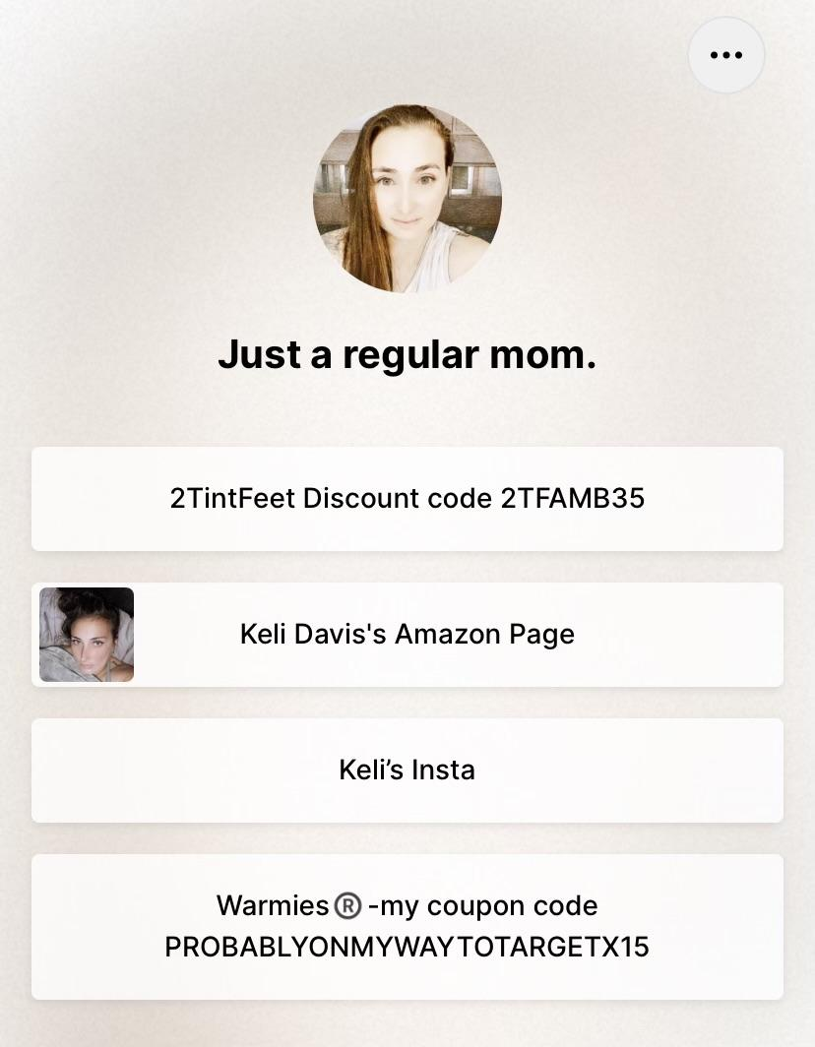

I found this affiliate link in the bio of a young mom’s Instagram by searching for pages that frequently posted to the hashtag #usemyaffiliatelink. The product that she is affiliated with is 2TinyFeet, which she misspells on the linktree. She is focused on creating content for young mothers but has few followers at just over a thousand. Her strategy for getting consumers to use her affiliate link is through the hashtag “usemyaffiliatelink”, which I imagine is for people who were going to buy the product and would like the discount. This is an ineffective use of affiliate advertising because it does not create any new impressions. Instead, it provides discounts for those who were planning to buy, along with giving the affiliate a stipend. While I am certain this was not the intention of the brand 2 Tiny Feet, they are ineffectively using their advertising resources and would have much more success with connecting to new consumers with other affiliate partnerships.